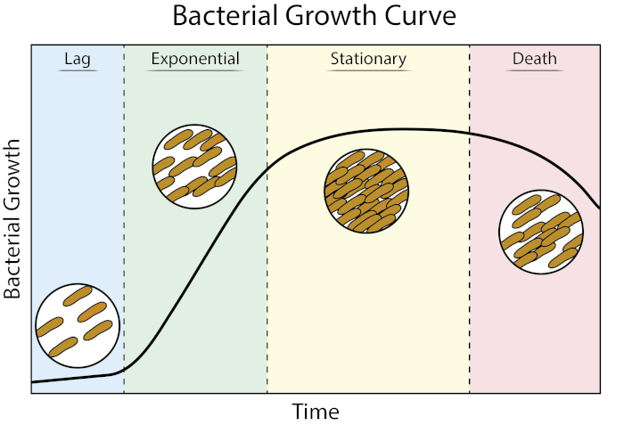

(<https://www.jove.com/v/10511/growth-curves-cfu-and-optical-density-measurements>)

(<https://en.wikipedia.org/wiki/Bacterial_growth>)

1. During **lag phase**, [bacteria](https://en.wikipedia.org/wiki/Bacterium) adapt themselves to growth conditions. It is the period where the individual [bacteria](https://en.wikipedia.org/wiki/Bacterium) are maturing and not yet able to divide. During the lag phase of the bacterial growth cycle, synthesis of RNA, enzymes and other molecules occurs. During the lag phase cells change very little because the cells do not immediately reproduce in a new medium. This period of little to no cell division is called the lag phase and can last for 1 hour to several days. During this phase cells are not dormant.[[4]](https://en.wikipedia.org/wiki/Bacterial_growth#cite_note-4)
2. The **log phase** (sometimes called the logarithmic phase or the *exponential phase*) is a period characterized by cell doubling.[[5]](https://en.wikipedia.org/wiki/Bacterial_growth#cite_note-Bacanova2008-5) The number of new bacteria appearing per unit time is proportional to the present population. If growth is not limited, doubling will continue at a constant rate so both the number of cells and the rate of population increase doubles with each consecutive time period. For this type of exponential growth, plotting the natural [logarithm](https://en.wikipedia.org/wiki/Logarithm) of cell number against time produces a straight line. The slope of this line is the specific growth rate of the organism, which is a measure of the number of divisions per cell per unit time.[[5]](https://en.wikipedia.org/wiki/Bacterial_growth#cite_note-Bacanova2008-5) The actual rate of this growth (i.e. the slope of the line in the figure) depends upon the growth conditions, which affect the frequency of cell division events and the probability of both daughter cells surviving. Under controlled conditions, [cyanobacteria](https://en.wikipedia.org/wiki/Cyanobacteria) can double their population four times a day and then they can triple their population.[[6]](https://en.wikipedia.org/wiki/Bacterial_growth#cite_note-:1-6) Exponential growth cannot continue indefinitely, however, because the medium is soon depleted of nutrients and enriched with wastes.
3. The **stationary phase** is often due to a growth-limiting factor such as the depletion of an essential nutrient, and/or the formation of an inhibitory product such as an organic acid. Stationary phase results from a situation in which growth rate and death rate are equal. The number of new cells created is limited by the growth factor and as a result the rate of cell growth matches the rate of cell death. The result is a “smooth,” horizontal linear part of the curve during the stationary phase. [Mutations](https://en.wikipedia.org/wiki/Mutation) can occur during [stationary phase](https://en.wikipedia.org/wiki/Stationary_phase_(biology)). Bridges et al. (2001)[[7]](https://en.wikipedia.org/wiki/Bacterial_growth#cite_note-pmid11166030-7) presented evidence that [DNA damage](https://en.wikipedia.org/wiki/DNA_damage_(naturally_occurring)) is responsible for many of the mutations arising in the genomes of stationary phase or starving bacteria. Endogenously generated [reactive oxygen species](https://en.wikipedia.org/wiki/Reactive_oxygen_species) appear to be a major source of such damages.[[7]](https://en.wikipedia.org/wiki/Bacterial_growth#cite_note-pmid11166030-7)
4. At **death phase** (decline phase), bacteria die. This could be caused by lack of nutrients, environmental temperature above or below the tolerance band for the species, or other injurious conditions.